Chapter 5:

Make a note of the followings:

| Topic | Description | Comment |
| --- | --- | --- |
| Spurious relationship | This occurs when a predictor has a high correlation with the other predictor and the outcome variable. And a predictor has positively correlated with the outcome variable, while the other predictor is negatively correlated. | The consequence is that an predictor has nearly perfect relationship with the outcome variable, while the other predictor has “zero” effect. |
| Masking effect | This occurs when two predictors are modelled separately they have no effects on the outcome. But when both are included in a model, they show good relationship with the outcome variable. | This phenomenon is called “masking”, as the separate modelling two predictors “masks” the relationship with the outcome variable. |
|  |  |  |
|  |  |  |
|  |  |  |
|  |  |  |
|  |  |  |
|  |  |  |

Chapter 5 Practice

5H1

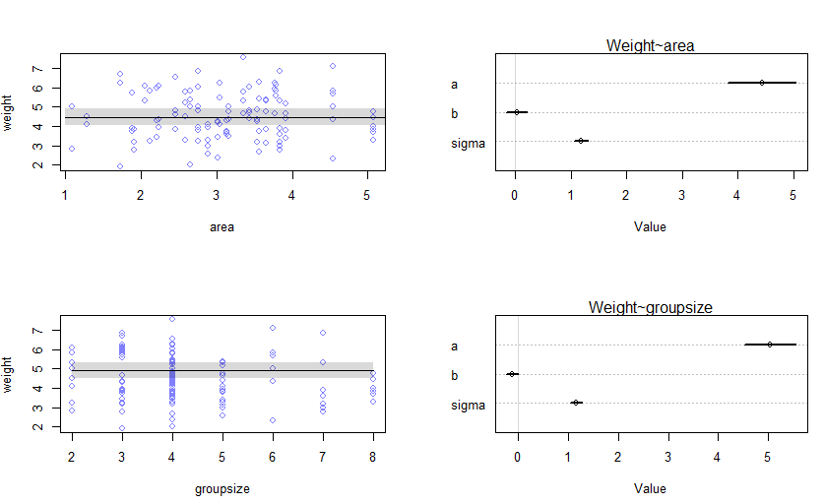

5H2

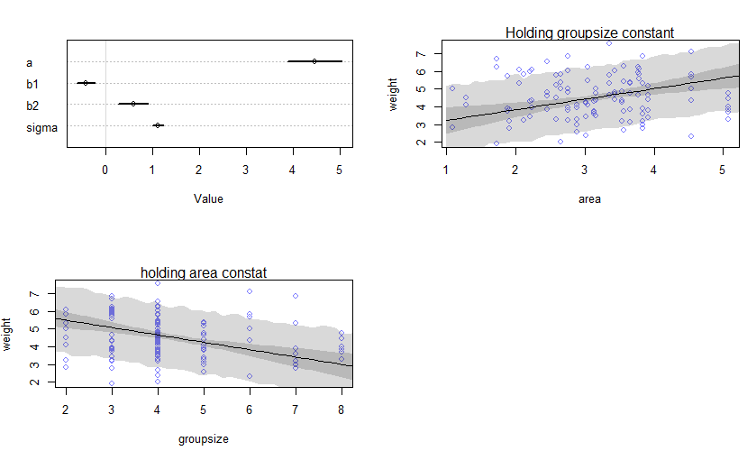

5H3

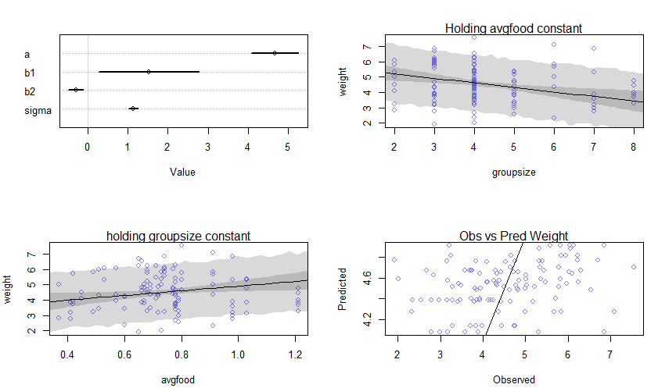

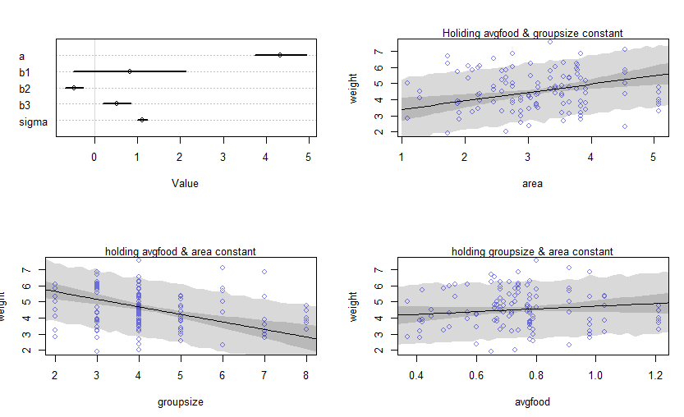

. b1: avgfood, b2:groupsize, b3:area

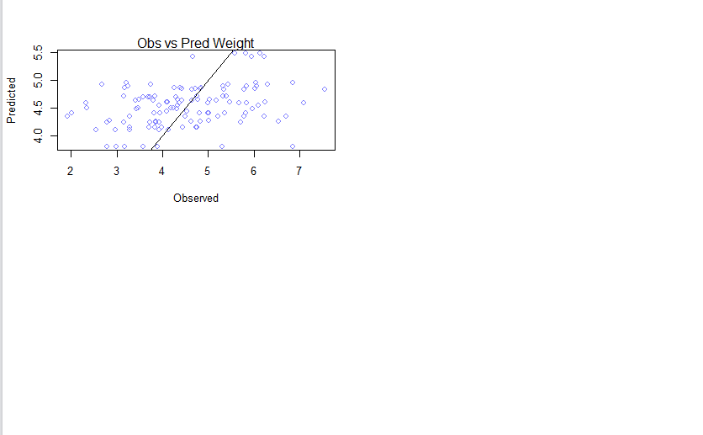

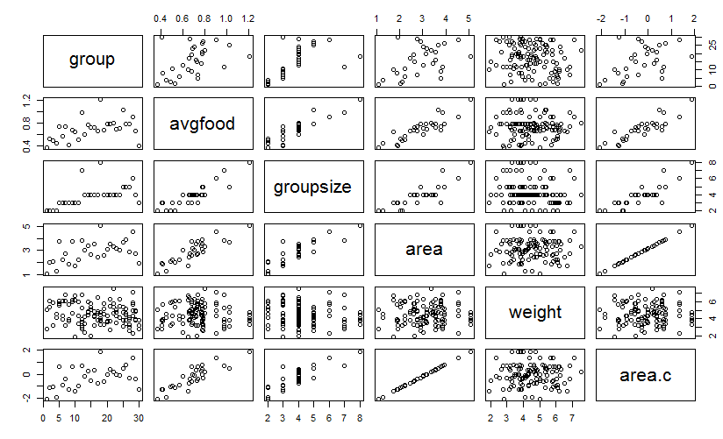

(a)

Avgfood gave a wider standard deviation than area in a model with group size and also when all three variables were included in a model, leading to a large uncertainty of the model. This results from a relatively high correlation between avgfood and area variables when viewed from a pair plot. As a result, the model should remove the avgfood variable and include the area variable.

(b)

This is because the correlation between avgfood and area variables are very high in such a way that their predictive values dropped in comparison to the model including either of them separately. When the two variables are very high in correlation the model seeks infinite number of combinations of parameter for finding MAP from a posterior distribution.